**Artificial Intelligence and Data Science Department.**

OOPM / Odd Sem 2021-22 / Experiment 14.

**____________________________________________________________**

YASH SARANG.

47 / D6AD.

EXPERIMENT - 14.

**____________________________________________________________**

**Aim:** To demonstrate the graphics font and Color class in java.  
**____________________________________________________________**

**Theory:** The Graphics class is the abstract superclass for all graphics contexts which allows an application to draw onto components that can be realized on various devices, or onto off-screen images as well.  
.**___________________________________________________________**

**PART: 01 House import**

**Program:***java.applet.Applet;*

*import*

*java.awt.Graphics;*

*import java.awt.Font;*

*import java.awt.*;*

*public class HouseExample extends Applet {*

*public void paint(Graphics g) {*

*Font f = new Font("TimesRoman", Font.BOLD, 20);*

*g.setFont(f);*

*g.drawString("HOUSE", 320, 180);*

*//MAIN BUILDING STRUCTURE*

*g.setColor(Color.red);*

*g.drawRect(250, 200, 200, 400);*

*g.fillRect(250, 200, 200, 400);*

*g.setColor(Color.green);*

*g.drawLine(250, 300, 450, 300);*

*g.drawLine(250, 400, 450, 400);*

*g.drawLine(250, 500, 450, 500);*

*//first row window one*

*g.setColor(Color.yellow);*

*g.drawRect(280, 230, 30, 30);*

*g.fillRect(280, 230, 30, 30);*

*//first row window second*

*g.setColor(Color.yellow);*

*g.drawRect(380, 230, 30, 30);*

*g.fillRect(380, 230, 30, 30);*

*//second row window first*

*g.setColor(Color.yellow);*

*g.drawRect(280, 330, 30, 30);*

*g.fillRect(280, 330, 30, 30);*

*//second row window second*

*g.setColor(Color.yellow);*

*g.drawRect(380, 330, 30, 30);*

*g.fillRect(380, 330, 30, 30);*

*//third row window first*

*g.setColor(Color.yellow);*

*g.drawRect(280, 430, 30, 30);*

*g.fillRect(280, 430, 30, 30);*

*//third row window second*

*g.setColor(Color.yellow);*

*g.drawRect(380, 430, 30, 30);*

*g.fillRect(380, 430, 30, 30);*

*// MAIN GATE*

*g.setColor(Color.yellow);*

*g.drawRect(330, 530, 50, 70);*

*g.fillRect(330, 530, 50, 70);*

*}*

*}*

*/\**

*<applet code="HouseExample" width="1000" height="1000">*

*</applet>*

*\*/*

**____________________________________________________________**

**OUTPUT:**

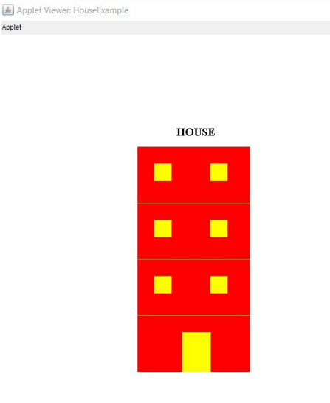

.**___________________________________________________________**

**PART 02: TRAFFIC SIGNAL**

*import java.applet.Applet;*

*import java.awt.Graphics;*

*import java.awt.Font;*

*import java.awt.*;*

*public class TrafficExample extends Applet {*

*public void paint(Graphics g) {*

*Font f = new Font("TimesRoman", Font.BOLD, 20);*

*g.setFont(f);*

*//MAIN SIGNAL BOX*

*g.setColor(Color.black);*

*g.drawRect(250, 200, 200, 400);*

*g.fillRect(250, 200, 200, 400);*

*g.setColor(Color.yellow);*

*g.drawLine(250, 300, 450, 300);*

*g.drawLine(250, 400, 450, 400);*

*g.drawLine(250, 500, 450, 500);*

*g.drawString("SIGNAL", 320, 550);*

*//RED CIRCLE*

*g.setColor(Color.red);*

*g.drawOval(330, 220, 50, 50);*

*g.fillOval(330, 220, 50, 50);*

*//GREEN CIRCLE*

*g.setColor(Color.green);*

*g.drawOval(330, 320, 50, 50);*

*g.fillOval(330, 320, 50, 50);*

*//YELLOW CIRCLE*

*g.setColor(Color.yellow);*

*g.drawOval(330, 420, 50, 50);*

*g.fillOval(330, 420, 50, 50);*

*}*

*}*

*/\**

*<applet code="TrafficExample" width="1000" height="1000">*

*</applet>*

*\*/*

**____________________________________________________________**

**OUTPUT:**

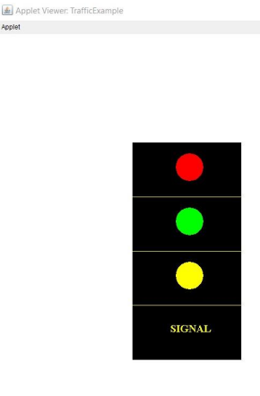**____________________________________________________________**

**PART: 03 JOKER**

*import java.applet.Applet;*

*import java.awt.Graphics;*

*import java.awt.*;*

*public class JokarExample extends Applet {*

*public void paint(Graphics g) { //MAIN CIRCLE*

*g.setColor(Color.red);*

*g.drawOval(300, 300, 600, 450);*

*g.fillOval(300, 300, 600, 450);*

*//FIRST EYE*

*g.setColor(Color.yellow);*

*g.drawOval(430, 380, 80, 80);*

*g.fillOval(430, 380, 80, 80);*

*//SECOND EYE*

*g.setColor(Color.yellow);*

*g.drawOval(700, 380, 80, 80);*

*g.fillOval(700, 380, 80, 80);*

*//MOUTH*

*g.setColor(Color.yellow);*

*g.drawOval(500, 550, 200, 50);*

*g.fillOval(500, 550, 200, 50);*

*//HAIR*

*g.setColor(Color.black);*

*g.drawOval(550, 280, 200, 50);*

*g.fillOval(550, 280, 200, 50);*

*/\**

*//LEFT EARS*

*g.setColor(Color.yellow);*

*g.drawOval(500,550,200,50);*

*g.fillOval(500,550,200,50);*

*//RIGHT EARS*

*g.setColor(Color.yellow);*

*g.drawOval(500,550,200,50);*

*g.fillOval(500,550,200,50);*

*\*/*

*}*

*}*

*/\**

*<applet code="JokarExample" width="1000" height="1000">*

*</applet>*

*\*/*

**____________________________________________________________**

**OUTPUT:**

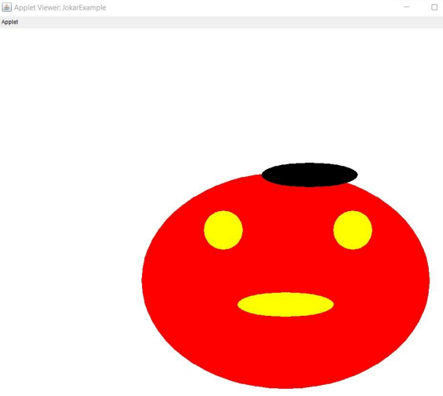

**____________________________________________________________**

**CONCLUSION:** In this experiment, we see the different classes of the applet and successfully perform the Experiment.

**____________________________________________________________**